TITLE | NN for any suitable application
PROBLEM STATEMENT / DEFINITION | Implementation of a simple NN for any suitable application (without tool)
OBJECTIVE | - To understand the classification problem  - To analyze the data  - Able to analyze classified data  - To analyze similarity between given database
S/W PACKAGES AND  HARDWARE APPARATUS USED | - Operating System : Latest version of 64 –Bit operating systems open source Fedora 20 or higher equivalent or Windows 8 with Multicore CPU equivalent to Intel i5 / 7 generation onwards  - Debain based OS ( Ubuntu 13.04 ) , g ++ , Python 2.7  - Programming Tools : Latest 64 –Bit Programming languages such as Microsoft Visual Studio ( ver. 12 or Higher ) or equivalent open source , Eclipse / QT 64 –Bit platform / IDLE editor  - Networked computer with internet access  - 32 / 64 –bit LATXT
REFERENCES | - A k-nearest neighbor based algorithm for multi-label classification , IEEE paper  - Introduction to k Nearest Neighbour Classification and Condensed Nearest Neighbour Data Reduction, Oliver Sutton February, 2012  - k-Nearest Neighbor Algorithm for Classification , K. Ming Leung, pdf  - Introduction to Data Miningand Knowledge Discovery, Third Edition by Two Crows Corporation, pdf
STEPS | Refer to theory, algorithm, test input, test output
INSTRUCTIONS FOR  WRITING JOURNAL | - Date  - Assignment no.  - Problem definition  - Learning objective  - Learning outcome  - Related Mathematics  - State transition diagram  - Concepts related Theory  - Program code with proper documentation.  - Output of program.  - Conclusion and applications (the verification and testing of outcomes)

Assignment No. B4

- Problem Statement
Write a program in C++ / Python to implement a simple NN for any suitable application (without tool).

- Prerequisites
- Object oriented programming features.

- Learning Objectives
- To understand the classification problem
- To understand nearest neighbor concept
- To analyze similarity between given data
- To analyze the data
- Able to analyze classified data

- Learning Outcome
- After successfully completing this assignment, you should be able to
- Understand & demonstrate by implementing simple NN classification.
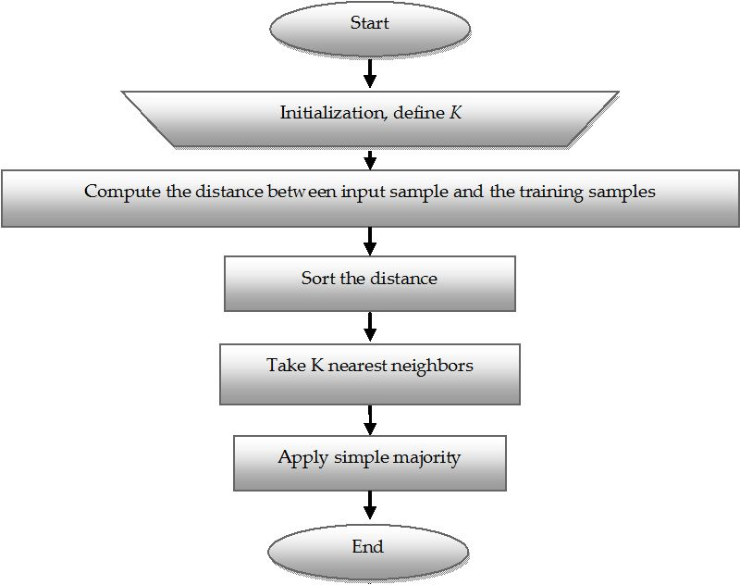

- Mathematical Model
Let S be the system such that,
S= {s, e, X, Y, f_score, f_sort, f_freq, f_predict, f_me, max}
where,
s = Starting point
e = End point
X = Input set
X = {X1, k, D}
where,
X1 = {x1, x2, x3, x4}
i.e. X1 contains attributes values which is to be classified.
Y= Output set
k = no. of K- nearest neighbor to consider
D = dataset containing no. of records with different attributes
D = {Rij; i = 1, 2, ……….m}
Ri = {a1, a2, a3, a4}
Where, a1, a2, a3,a4 are different items in database.
f_predict() find out the score or distance of given specification with dataset and return the
item which is occured maximum in nearest k values.
f_me = f_predict(X)
f_predict(X) = f_score(X) --> Li
f_score is function for calculating distance.

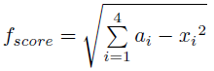

f_sort() function gives items in Li in sorted order
f_sort(Li)--> {l0, l1, …..|li < li+1}
f_freq peak up top k items which are very much nearest to input specification which is to be
classified.
f_freq = {Fi € i = 0, 1,………., k}
max = MAX(Fi)
max contains the name of class in which X1 is classified and it take the class which occurs
maximum times in k items.
Y = max

- Algorithm :
Step 1: Initialize value of K.
Step 2: Calculate distance between input sample and training samples.
Step 3: Sort the distances.
Step 4: Take top K- nearest neighbors.
Step 5: Apply simple majority.
Step 6: Predict class label for input sample.

- Function Dependency Diagram:

F_{me}

F_{predict}

F_{sort}
F_{score}
F_{[freq}

- Concepts related Theory
KNN is a simple algorithm that stores all available cases and classifies new cases based on a similarity measure. In pattern recognition, the k-Nearest Neighbors algorithm (or k-NN for short) is a non-parametric method used for classification and regression. In both cases, the input consists of the k closest training examples in the feature space. The output depends on whether k-NN is used for classification or regression:
- In k-NN classification, the output is a class membership. An object is classified by a majority vote of its neighbors, with the object being assigned to the class most common among its k nearest neighbors (k is a positive integer, typically small). If k = 1, then the object is simply assigned to the class of that single nearest neighbor.
- In k-NN regression, the output is the property value for the object. This value is the average of the values of its k nearest neighbors.
k-NN is a type of instance-based learning, or lazy learning, where the function is only approximated locally and all computation is deferred until classification. The k-NN algorithm is among the simplest of all machine learning algorithms.
The neighbors are taken from a set of objects for which the class (for k-NN classification) or the object property value (for k-NN regression) is known. This can be thought of as the training set for the algorithm, though no explicit training step is required.
A shortcoming of the k-NN algorithm is that it is sensitive to the local structure of the data. The algorithm has nothing to do with and is not to be confused with k-means, another popular machine learning technique.
- Test Methods
- Black box Testing
- White box testing
- Manual Testing & / or Unit testing

Sr. No. | Test Case | Actual output | Expected output
 | Validate input value of K |  | K must be +ve integer.
 | Validate classified data

- Review Questionnaire:
1. What are K- nearest neighbor algorithm ?
2. How K-NN actually works?

- Conclusion :
Thus, after successfully completing this assignment, you should be able to understand & implement K-NN algorithm in C++ / Python.

TITLE | K-means clustering algorithm.
PROBLEM STATEMENT / DEFINITION | Write a program in C++/python to implement k-means for clustering data of children belonging to different age groups to perform some specific activities. Formulate the Feature vector for following parameters:  i. height  ii. weight  iii. age  iv. IQ  Formulate the data for 40 children to form 3 clusters
OBJECTIVE | - To understand clustering concept.  - To understand K-means clustering algorithm.  - To understand new technique of grouping given data into specified number of groups.  - To analyze given data.
S/W PACKAGES AND  HARDWARE APPARATUS USED | - Operating System : Latest version of 64 –Bit operating systems open source Fedora 20 or higher equivalent or Windows 8 with Multicore CPU equivalent to Intel i5 / 7 generation onwards or Kali Linux  - Programming Tools : Latest 64 –Bit Programming languages such as Microsoft Visual Studio ( ver. 12 or Higher ) or equivalent open source , Eclipse / QT 64 –Bit platform  - Networked computer with internet access  - 32 / 64 –bit LATXT
REFERENCES | An efficient k-means clustering algorithm: analysis and implementation , IEEE paper  - An Efficient K-Means Clustering Algorithm by Khaled Alsabti, Sanjay Ranka, Vineet Singh  - K-Means Cluster Analysis, pdf.  - K-MEANS CLUSTERING, ppt
STEPS | Refer to theory, algorithm, test input, test output
INSTRUCTIONS FOR  WRITING JOURNAL | - Date  - Assignment no.  - Problem definition  - Learning objective  - Learning outcome  - Related Mathematics  - State transition diagram  - Concepts related Theory  - Program code with proper documentation.  - Output of program.  - Conclusion and applications (the verification and testing of outcomes)

Assignment No. B5-9

- Problem Statement
Write a program in C++/python to implement k-means for clustering data of children belonging to different age groups to perform some specific activities. Formulate the Feature vector for following parameters:
i. height
ii. weight
iii. age
iv. IQ
Formulate the data for 40 children to form 3 clusters.

- Prerequisites
- Object oriented programming features.

- Learning Objectives
- To understand clustering concept.
- To understand K-means clustering algorithm.
- To understand new technique of grouping given data into specified number of groups.
- To analyze given data.

- Learning Outcome: After successfully completing this assignment, you should be able to
- Understand & demonstrate by implementing K-means for clustering data.
- Understand the grouping of data into clusters based on distance measure.

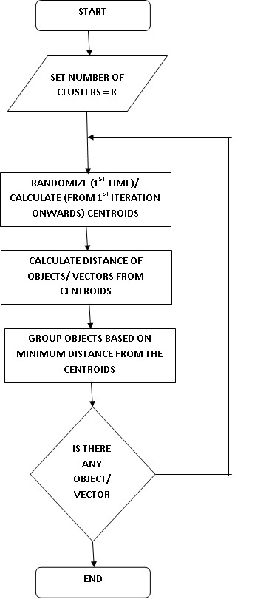

- Mathematical Model
Let us consider S as a solution perspective of the email header analysis system
S= { s, e, X, Y, K, f_me, f_random, f_cluster, f_centroid | ∅ }
s = Starting point
e = End point
X = Input set
X = {x1, x2, x3, x4, ….,}
Where, x1, x2, x3, x4, …. are different data items to be classified.
Y= Output set
K is number of clusters to be formed
f_me= X → Y
f_random is a function that initially chooses k-centroids for k-clusters.
f_cluster is a function that assigns different data items to nearest centroid cluster depending on eucledian distance.
f_centroid calculates the new centroid depending on clustered value.

f_me : {X,K} → Y
X1

X2

X3

X4
…
...
.

K1

K2

K3

doma

- Algorithm:
Step 1: Begin with a decision on the value of k = number of clusters .
Step 2: Put any initial partition that classifies the data into k clusters. You may assign the training samples randomly,or systematically as the following:
1.Take the first k training sample as single-element clusters
2. Assign each of the remaining (N-k) training sample to the cluster with the nearest centroid. After each assignment, recompute the centroid of the gaining cluster.
Step 3: Take each sample in sequence and compute its distance from the centroid of each of the clusters. If a sample is not currently in the cluster with the closest centroid, switch this sample to that cluster and update the centroid of the cluster gaining the new sample and the cluster losing the sample.
Step 4: Repeat step 3 until convergence is achieved, that is until a pass through the training sample causes no new assignments.

A Simple example showing the implementation of k-means algorithm (using K=2).

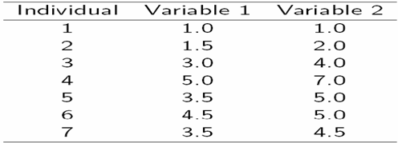

Step 1:
Initialization: Randomly we choose following two centroids (k=2) for two clusters.
In this case the 2 centroid are: m1=(1.0,1.0) and m2=(5.0,7.0)

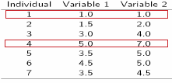

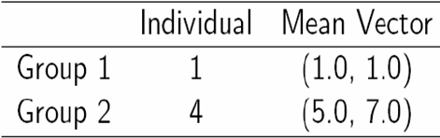

Step 2: Thus, we obtain two clusters containing: {1,2,3} and {4,5,6,7}.
Their new centroids are:

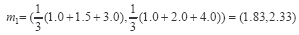

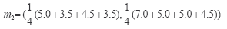

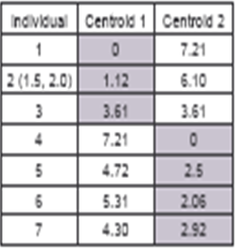
Step 3: Now using these centroids we compute the Euclidean distance of each object, as shown in table.
Therefore, the new clusters are: {1,2} and {3,4,5,6,7}
Next centroids are: m1=(1.25,1.5) and m2 = (3.9,5.1)

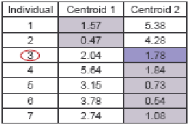

Step 4 : The clusters obtained are: {1,2} and {3,4,5,6,7}
Therefore, there is no change in the cluster.
Thus, the algorithm comes to a halt here and final result consist of 2 clusters {1,2} and {3,4,5,6,7}.

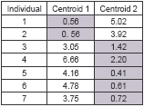

PLOT:-

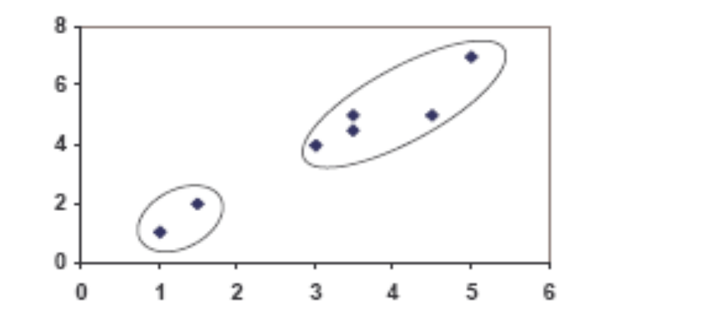

With K=3

Step 1:

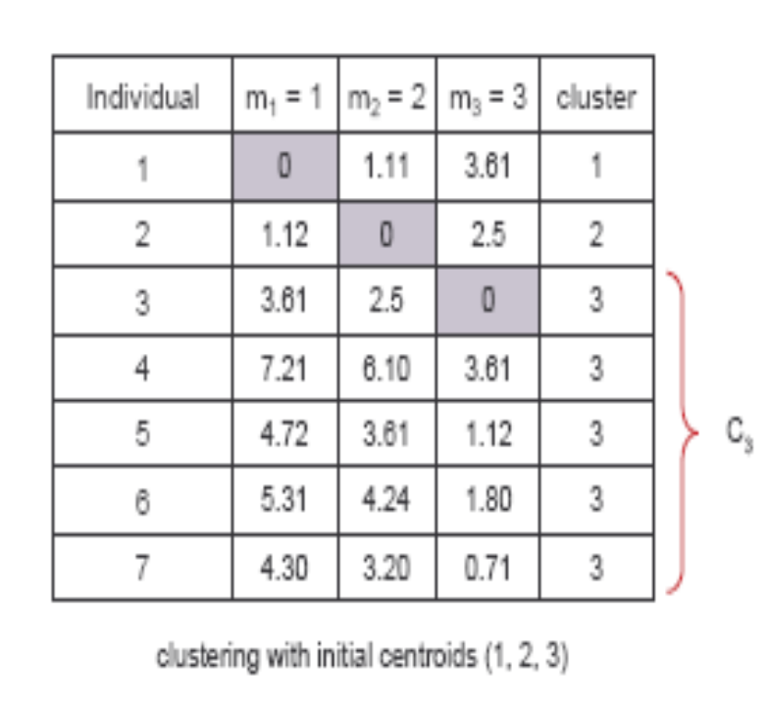

Step 2:

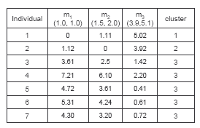

PLOT:-

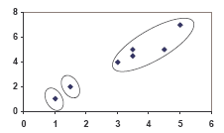

- Concepts related Theory
Introduction to Clustering :
Cluster analysis or clustering is the task of grouping a set of objects in such a way that objects in the same group (called a cluster) are more similar (in some sense or another) to each other than to those in other groups (clusters).
The goal of clustering is to organize data by finding some ‘sensible’ grouping of the data items. Clustering is unsupervised learning because it doesn’t use predefined category labels associated with data items. A cluster is a set of objects that are similar, objects from different clusters are not similar. k-means clustering is a method of vector quantization, originally from signal processing, that is popular for cluster analysis in data mining.

K- means Clustering algorithm
k-means clustering is a partitioning method. The function k-means partitions data into k mutually exclusive clusters, and returns the index of the cluster to which it has assigned each observation. Unlike hierarchical clustering, k-means clustering operates on actual observations (rather than the larger set of dissimilarity measures), and creates a single level of clusters. The distinctions mean that k-means clustering is often more suitable than hierarchical clustering for large amounts of data.
kmeans treats each observation in your data as an object having a location in space. It finds a partition in which objects within each cluster are as close to each other as possible, and as far from objects in other clusters as possible. You can choose from five different distance measures, depending on the kind of data you are clustering.
Each cluster in the partition is defined by its member objects and by its centroid, or center. The centroid for each cluster is the point to which the sum of distances from all objects in that cluster is minimized. kmeans computes cluster centroids differently for each distance measure, to minimize the sum with respect to the measure that you specify.
kmeans uses an iterative algorithm that minimizes the sum of distances from each object to its cluster centroid, over all clusters. This algorithm moves objects between clusters until the sum cannot be decreased further. The result is a set of clusters that are as compact and well-separated as possible. You can control the details of the minimization using several optional input parameters to kmeans, including ones for the initial values of the cluster centroids, and for the maximum number of iterations. By default, kmeans uses the k-means++ algorithm for cluster center initialization and the squared Euclidean metric to determine distances.
The most common algorithm, described below, uses an iterative refinement approach, following these steps:
- Define the initial groups' centroids. This step can be done using different strategies. A very common one is to assign random values for the centroids of all groups. Another approach is to use the values of K different entities as being the centroids.
- Assign each entity to the cluster that has the closest centroid. In order to find the cluster with the most similar centroid, the algorithm must calculate the distance between all the entities and each centroid.
- Recalculate the values of the centroids. The values of the centroid's fields are updated, taken as the average of the values of the entities' attributes that are part of the cluster.
- Repeat steps 2 and 3 iteratively until entities can no longer change groups.
The K-Means is a greedy, computationally efficient technique, being the most popular representative-based clustering algorithm.

- Algorithm: k-means
1. Decide on a value for k.
2. Initialize the k cluster centers (randomly, if necessary).
3. Decide the class memberships of the N objects by assigning them to the nearest cluster center.
4. Re-estimate the k cluster centers, by assuming the memberships found above are correct.
5. If none of the N objects changed membership in the last iteration, exit. Otherwise goto 3.

- Test Methods
- Black box Testing
- White box testing
- Manual Testing & / or Unit testing

Sr. No. | Test Case | Actual output | Expected output
1 | Validate input value of K | - | K must be +ve integer
2 | Validate clustered data | -

- Review Questionnaire:
1. What is clustering ?
2. What is the goal of clustering ?
3. What is k-means clustering algorithm ?
4. Explain how k-means algorithm works with example.

- Conclusion :
Thus, after successfully completing this assignment, you should be able to understand & implement K-means clustering algorithm.

